FAQs

1. **What should I bring to my Hostel?**
2. Locks
3. Table Lamps
4. Broom, Dust cleaning brush
5. Dusting Cloth
6. Dustbins and Dustbin polybags
7. Doormats

Toiletries

1. Bathing Soaps
2. Shampoo
3. Face Packs
4. Hair Oil/Gel
5. Comb
6. Toothbrushes, Toothpaste
7. Shaving Kit
8. Washing Powder and Brush
9. Buckets and mugs
10. Hand wash

Cosmetics

1. Powder
2. Deodorants (you will need it!)
3. Creams and Moisturisers

Miscellaneous and Stationary

1. Medicines
2. School Bag
3. Textbooks from book lending scheme
4. Pens, Pencils etc
5. Rough Papers/Books
6. Scientific Calculator
7. Stapler and Punch holes
8. Hangars for clothes

Necessary Things

1. Academic Original Documents (To be submitted for verification, EAMCET Documents, Xeroxes #Do whatever is asked by college management)
2. Other Personal Documents (Scholarship documents, Passport, Aadhaar Card, Passport sized photos)
3. Alarm Clock
4. Pendrive
5. Laptop
6. Iron
7. Clips to hang your clothes
8. Torch /Emergency Light
9. Bring anything that interests you or you have a passion for!
10. Gaming accessories

**2) When should i start worrying ( when are mid and sem exam?)**

Most people in your friend group and most of your batchmates will only worry about exams one day before they have it

As a fresher, it is advised for you to maintain a good gpa in your first year, as it is easier to get good grades in 1st year compared to the latter years

Check the academic calendar from the college website for more info regarding dates

<https://sreenidhi.edu.in/academic-calendars/>

**3) what is the minimum attendance and how do i check mine?**

The minimum attendance is 75% with a 10% relaxation with a condonation fee, so it is in actuality a 65%

You can check your attendance using a student created attendance portal

<https://snist.netlify.app/login>

**4)Any Advice for coding, development enthusiasts ?**

1. Take two hours out for DSA practice everyday. There is enough sources to study and practice, just make sure you give your ample time to master it. Also, the later you start DSA, the more time a day you need to take out for it.
2. Find people who are doing coding projects on their own. If you want, get inspiration from it, study about it enough to explain to understand the concept.

**5) what are clubs? And should i join them?**

Clubs are student groups that share a common interest in a field, you will find multiple clubs in SNIST here is the list

1. Robotics Club ·
2. Art's Club ·
3. Tech Vision Club ·
4. ECA Club ·
5. Bachpan Prayas Club ·
6. SPC
7. IEEE
8. Electronix club
9. AI club
10. Sports club
11. NSS

Do note, Join clubs in the first year but not many, make sure to focus on one where there's a better chance of promotion and the one you have a genuine interest in . Don't join clubs after first year, they will just slave off your labour and won't reward you.

**6) what are the places to eat around the campus and is there a stationary?**

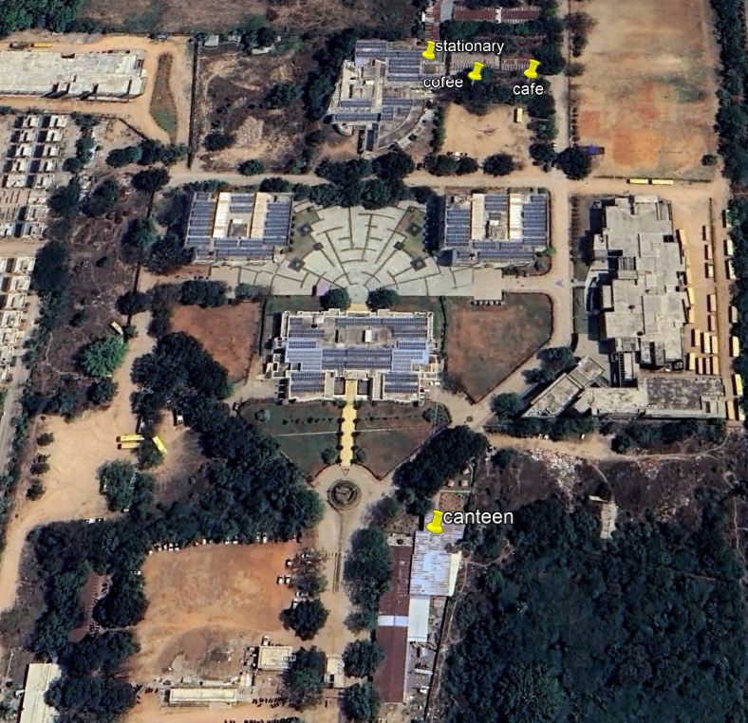

**A message from a senior to juniors**

1. Study well and maintain a decent GPA. GPA is often the criteria that companies set for shortlisting candidates when they come for campus recruitment.
2. Enhance your skills. Try searching on the internet about skills that are in demand in your field and start gaining them right away. Helps for sure in the longer run.
3. Socialize with people. Do not confine yourself to a shell. Socialize and participate whole heartedly in curricular and extra curricular events. Note that winning is not important but participating is. It makes you confident, shapes your personality and makes you a better team player.
4. Finally enjoy life. Student days won't come back once they are gone. These are fun days and believe me you should not miss out on making memories. It is these memories which you will cherish in future.

**Some more advice from anonymous seniors**

**7) what is a mentor and why are they important for you?**

Several students decide midway through the school year that they are not interested in engineering. Maybe they don’t want to work in their field of study. Make sure you’re getting the correct guidance and making an informed decision based on your interests and not the aptitude to overcome this type of difficulty, which is common and manageable.

You can get help with that via mentoring. Find yourself a mentor. In order to help you discover your ideal job path, they offer comprehensive career assessments to help you identify the points where your personality, interests, and abilities come together.

**8) How do i make friends and become more social?**

If you want to pick and choose your buddies, it won’t work. Your degree’s most crucial components are networking, interacting with others, and receiving or offering assistance. Maintain a positive social profile since you never know who you might need to aid you in the future. It’s possible that you won’t always get to work with the partner you wanted, but view it as a challenge and develop the ability to get along with and collaborate with a variety of people. Keep in mind that a good leader goes alongside the group, not in front of it.

**9) Campus Life, Comfort zone,How to lead a good college life**

You should learn discipline and manners on campus so that you may use them for the rest of your life. To encourage students to step outside their comfort zone and experience a hard yet rewarding stage of life, every B.Tech college should feature a student-centered campus life. Students may find it difficult to adjust to college life in their first year, but a vibrant campus community would make it easier. You will learn things in four years of engineering college that you would not have learned in a lifetime.

**10) Is college stressful? How to manage stress?**

The tension indicated above cannot be avoided, however, the workload also relies on your chosen B. Tech College and stream. Avoiding comparisons with others and taking care of your health as you travel far, stay up late, and balance your personal life with your course are the keys to minimizing stress.

**11)How is Competition in college?**

The hurdles you face in each year of the engineering program vary depending on your B.Tech College and stream of choice. While you might be able to handle everything by the second year, you might need to schedule every minute of your first year of B.Tech colleges. Ask your seniors about their experiences in college, the instructors, placement cell opportunities, and other topics. They might not have the most uplifting responses, but they will let you know what to anticipate and how to get ready for it.

Determine the difficulties and psychologically get ready for them. Remember, though, that despite all your preparation, tension can still arise and be debilitating. Now and then, give your mind a restful moment to recover. You have reached the point where everyone is expected to operate quickly in the real world, where you will thereafter be expected to perform. Consider this your practice area.

.**12) College fests, How many do we have?**

Snist has a rich culture of having a lot of fests, our clubs organize about 5 fests every year

1. Adastra - IEEE
2. Rigolade - Arts club
3. Sreevision - ICSquare
4. Roboveda - Robotics club
5. Ascendo - IEC club